*Abstract*— **The proposed system applies to all Police**

**stations across the country and specifically looks into the subject of Crime Records Management. It is well understood that Crime Prevention, Detection and Conviction of criminals depend on a highly responsive backbone of Information Management. The efficiency of the police function and the effectiveness with which it tackles crime depend on what quality of information it can derive from its existing records and how fast it can have access to it. Initially, the system will be implemented across Cities and Towns and later on, be interlinked so that a Police detective can access information across all records in the state thus helping speedy and successful completion to cases. The project has been planned to be having the view of distributed architecture, with centralized storage of the database. The application for the storage of the data has been planned. Using the constructs of SQL server and all the user interfaces have been designed using the DOT Net technologies.**

***Keywords***— **crime, criminals, investigators, lawyers.**

I. INTRODUCTION

The Crime Records Management System applies to Police Stations all across the country and specifically looks into the subject crime prevention, detection, conviction of criminals depending on a highly responsive backbone of Information Management [1]. The efficiency of the Police and the effectiveness with which it tackles crime depend on what quality of information it can derive from its existing records and how fast it can have access to it. [2][3]

A. *Modules*

1. *Station module:*

Each of the station must first register with the Software. For the registration part each station enter their details like station name, address, phone no, station in charge etc. and get a User Id from the Software. Once the prospective station registers records.

1. *Citizen module:*

Each of the citizens, who has a complaint to register, must first register with the Software. For the registration part each person enter their details like name, address, phone no., E-Mail ID etc. and get a User Id & password from the Software. Once the registration is complete, the citizen can sign-in to the website & register their complaint.

1. *Crime module:*

This module is used for entering all details about the crime. It contains the date and time, police station where it is recorded, place, Nature of Crime, Location of the Crime etc.

1. *Search module:*

In this module we can search the crime in station wise, nature of crime.

1. *Administrators Module:*

The module will be protected by user ID and password. Ordinary users of the software will not be permitted to enter into this area of the software. The module will be focusing on the maintenance like Master Data Maintenance, Removal of old and outdated data from the software etc.

1. *Avocation Module:*

This Module deals with the Law part of every Crime. [3]

* 1. SYSTEM ANALYSIS

System Analysis works with users to identify goals and build systems to achieve them. System analysis is an important phase of any system development process. The system is studied to the minutest details and analyzed. The system analyst plays the role of an interrogator and dwells deep in to the working of the present system. In analysis, a detailed study of these operations performed by a system and their relationships within and outside of the system is done. A key question considered here is, “what must be done to solve the problem?” One aspect of analysis is defining the boundaries of the system and determining whether or not the candidate system should be considered. The system is viewed as a whole and the inputs to the system are identified. The outputs from the system are traced through the various processing that the input phases through in the organization. During analysis, data are collected on available files, decision points, and transaction handled by present system. Once analysis is completed the analyst has a firm understanding of what is to be done.

* 1. EXISTING SYSTEM

In the existing crime management system, most of the operations are done manually like send complaints, taking actions against crimes, view status etc. So with the existing system if anybody wants to complaint against crimes he must do it through the police. If we are doing the system manually, so many minor errors will occur. Error detection in the previous entries made and data cross verification is another important function. These are done manually, and it would take time.

*1) Drawbacks of the existing system can be concluded as follows:*

The existing system is time consuming and not very user friendly.

The officer dealing with a particular case cannot take decision by himself even when he is having the first hand knowledge/information about the case and he can expect obstructions from higher authorities/officials.

Even an efficient officer cannot/may not able to handle more than one case at a time.

In most of the cases, the innocent are accused in the existing system.

As per our jurisdiction, “Let thousand criminals escapenot a single innocent be punished “. As a result of this and other factors that influence investigation, such as bribery, the innocent becomes accused in several situations in the eyes of Justice.

The existing system could provide only investigation and there is no Advocating, Counseling facilities etc. hence no contact or control or co-ordination on these cell. [4]

IV. PROPOSED SYSTEM

Our mission statement directs us to promote the public interest while balancing the Law. Obviously we’ll not rush to judgment, but will look at the facts and render a thoughtful decision based on these facts. Organization is an independent statutory body which was created to maintain an effective an effective and efficient police service for the public. Its primary task includes securing continuous needs of the public in an efficient manner. As part of the responsibility, ‘our committee’ is responsible for performance monitoring (performance planning and review formerly professional standards and performance monitoring) decided to look at the contribution and effectiveness of the organization within the public. We need the whole hearted support of each and every individual member of the site and cooperation of the users. The administrator, along with the investigators, lawyers, counselors, and other authorities statutory partners in our organization. Given their key role in these partnerships, we felt that an overview of strength and Weakness of the organization is needed.

The aim of the project is to bring about improvement to the organization’s contributions; this report necessarily concentrates on overcoming weakness and raising standards. To avoid conducting and unfair evaluation efforts which are made to put this contribution into this context. It believes that partnership work is highly beneficial to the organization and that partnership work is the way forward to reduce crime and disorder.

1. *Advantages of the Proposed System:*

Better communication, better leadership, better training, more defined roles in terms of contribution to contribution to the society.

Working with partners.

Reducing crime and disorder. Fig. 1.Page Name: from Login Page

Confidently and anonymity issues. 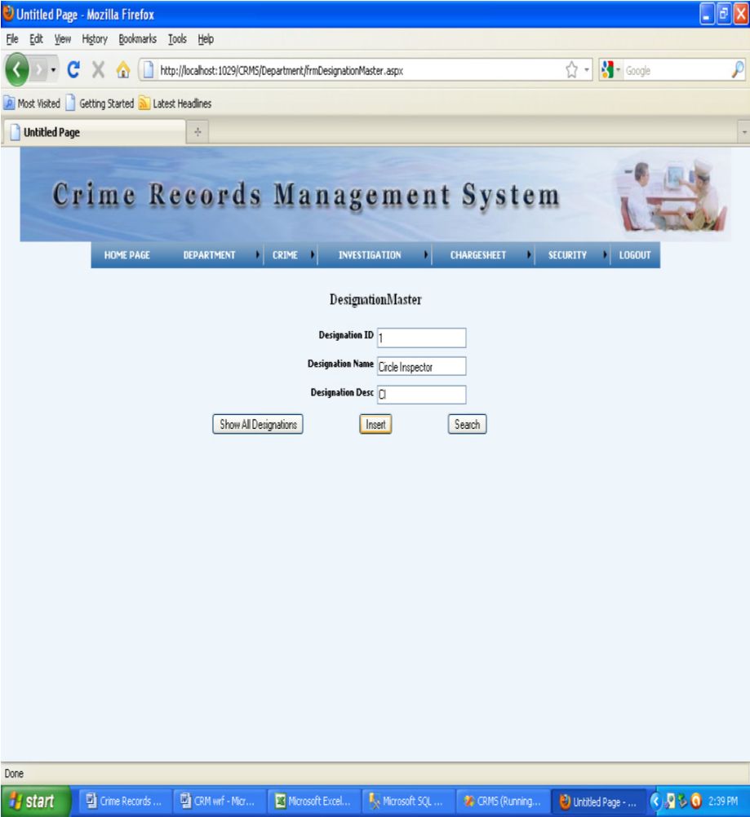

The proposed system has control over all its cells and is perfectly coordinated. Also the cells can act individually. To take our organization to heights we need the wholehearted co-operation of the public.

1. *Objectives of the Proposed System*

In the fast moving world, if people lack something, it is time. All are busy in their world. So the main objective of our product is better communication, better leadership, reducing crime and disorder etc.The product provides a framework within which a user can easily work with. We know users are of many categories, like users from who know working with computers very well to users

who didn’t know about computers. So all the category can use the software. So it should be user friendly.

The product provides a framework, which is Fig. 2.Page Name: from DesignationMaster.aspx error free. We know a crime management system is

actually a critical process having many calculations and operations. So each simple error laid to big problem. So it should be error free and our objective is to build error free software.

1. SNAPSHOTS 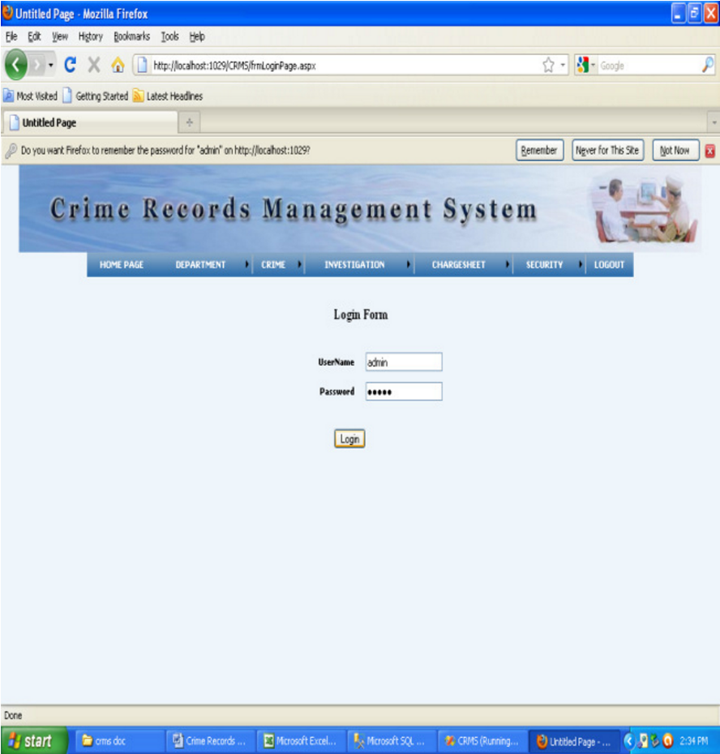

Fig. 3 Page Name: from Dep Emp Master 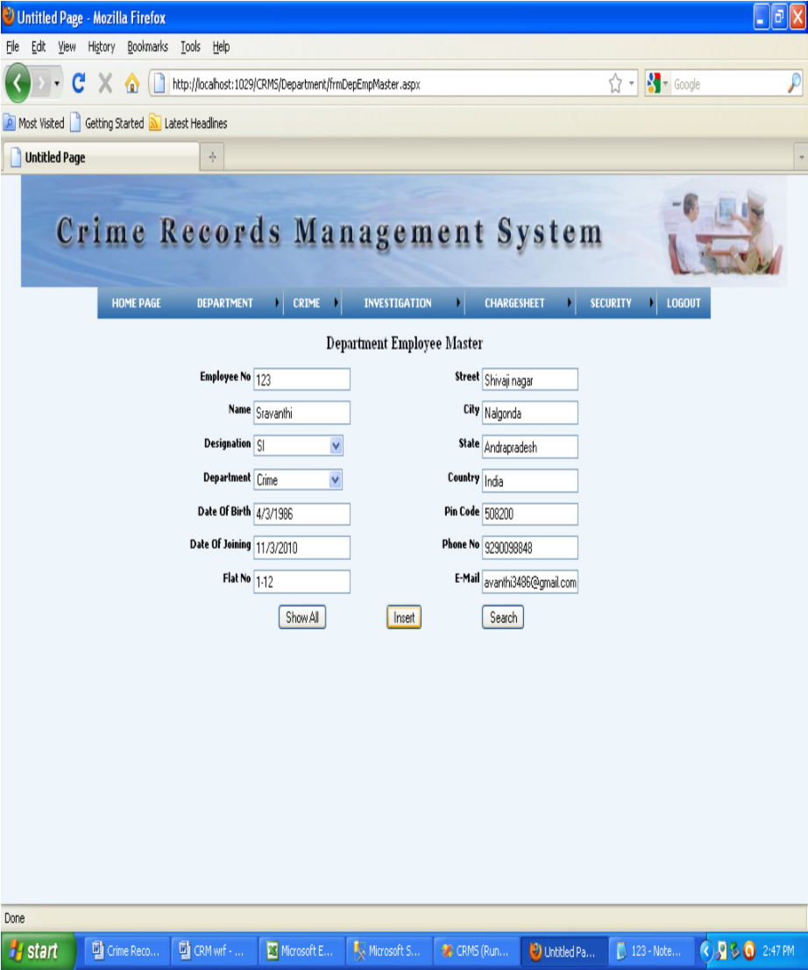

When we want see all department employees then click on show all department button then we get the data from table and also we will modify that data.

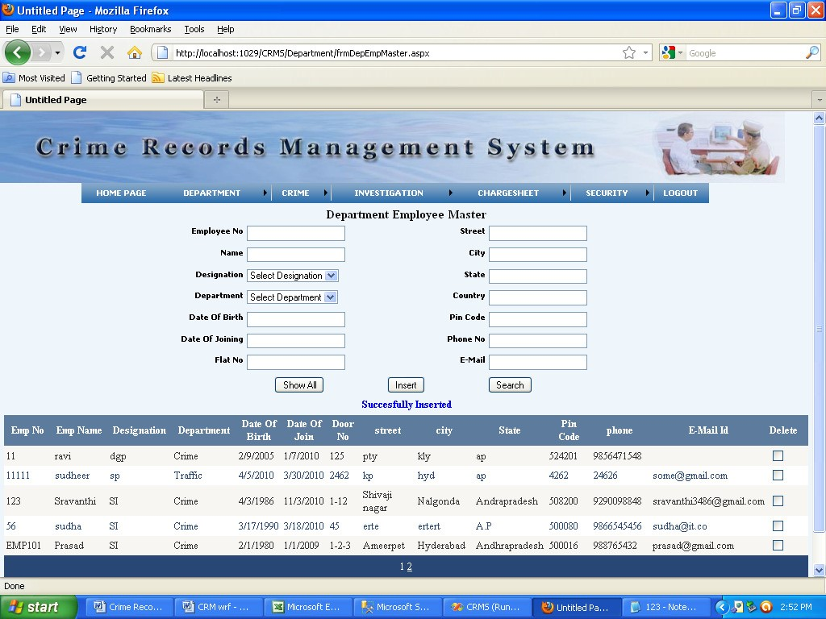

Fig. 4 Show all department

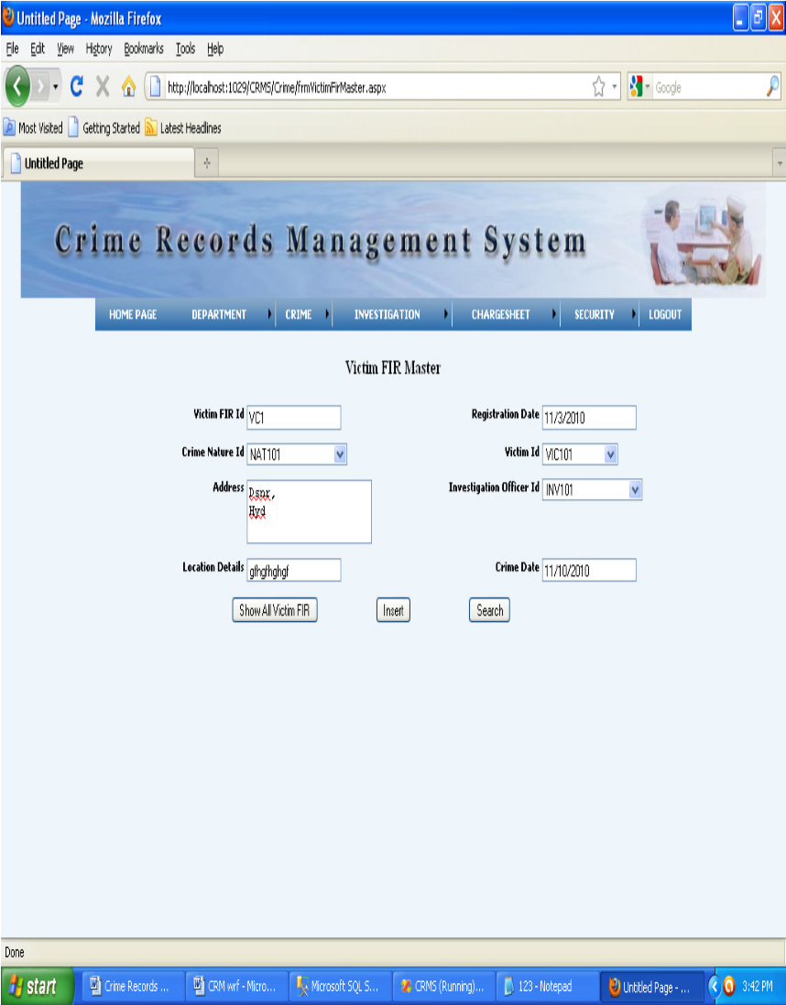

Fig. 5.Page Name from Victim Fir Master.aspx

1. CONCLUSION

The Software developed is found to be working efficiently and effectively. It results in regular and timely action against crime reported. It can be observed that the information can be obtained easily and accurately. The Software is made user friendly to the maximum so that any lay man can run the software provided he could access to the system via the login password. It believes that partnership

work is highly beneficial to the organization and that partnership work is the way forward to reduce crime and disorder. Hence, we wish to remind that its culture should fully endorse partnership work; we urge to ensure the attention they require.

|  |  |  |
| --- | --- | --- |
|  |  |  |
|  | [1] | http://en.wikipedia.org/wiki/Criminal_record |
|  | [2] | http://thinknext.co.in/rupali/homepage.aspx |
|  | [3] | Anil Jaiswal, Neeta Gunjal, PoojaLondhe, Shikha Singh, Ramesh Solanki, “Crime Automation & Reporting System” ,International Journal of Science and Modern Engineering (IJISME),Volume-1,  Issue-11, October 2013 |
|  | [4] | http://topicideas.org/how-to-online-crime-reporting-and-managementsystem-pdf |
|  |  |  |

REFERENCES